**CS 401 ARTIFICIAL INTELLIGENCE SECTION B FAST NU, LAHORE CAMPUS**

**MIDTERM 2 EXAM SOLUTIONS April 11, 2013.**

**QUESTION 1 (Marks: 8+2)**

1. Design a **single perceptron** that can learn to discriminate the labels for the following data so that the perceptron makes minimum classification errors. Clearly specify the weights and the activation function and draw the perceptron. Show all working clearly.
2. How many errors does your perceptron make and for which points?

|  |  |  |
| --- | --- | --- |
| x1 | x2 | Label |
| 0 | 0 | +1 |
| -1 | 0 | +1 |
| -3 | 0 | -1 |
| -1 | 4 | -1 |
| 1 | -1 | +1 |
| -2 | 2 | -1 |
| 5 | -1 | -1 |

SOLUTION

This can be solved by observation by plotting the points:



You can see that we have a minimum of one training error for this data for the point (5, -1). The line shown can be one possible solution. The equation of this line is:

4 + 2x1 –x2 = 0

the required perceptron is shown below:

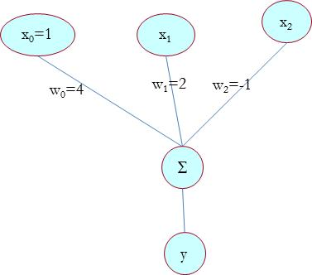

The output y from this perceptron is a threshold function given by:

f(x) = +1 if x >= 0

f(x) = -1 otherwise

**QUESTION 2 (Marks: 2+3+5)**

**Show all working clearly**

1. For the shown neural network, all inputs are binary and all units use the activation function given by f(a), so the output of each unit is either a **zero or a one**. What is the output of this network when the following inputs are given:

|  |  |  |  |
| --- | --- | --- | --- |
| 1. (0,0,0) 2. (1,1,0) 3. (1,1,1) 4. (1,0,1) |  | f(a) =1 if a>0  f(a) = 0 otherwise |  |

ii) Which Boolean expression does this network represent?

1. Is it possible to design an equivalent neural network with no hidden layers to represent the same problem? If so draw it, and if it is not possible then give a suitable justification.

SOLUTION

1. a. 0 b. 0 c. 1 d. 1
2. h1 = f(-1+2x1-2x2) = x1 ^ ~x2

h2 = f(-3+2x2+2x3) = x2 ^ x3

h3 = f(-3+2x1+2x3) = x1 ^ x3

y = h1 v h2 v h3 = (x1 ^ ~x2 ) v (x2 ^ x3) v (x1 ^ x3)

1. for the eight possible inputs we have the following outputs:

|  |  |  |  |
| --- | --- | --- | --- |
| x1 | x2 | x3 | Output |
| 0 | 0 | 0 | 0 |
| 0 | 0 | 1 | 0 |
| 0 | 1 | 0 | 0 |
| 0 | 1 | 1 | 1 |
| 1 | 0 | 0 | 1 |
| 1 | 0 | 1 | 1 |
| 1 | 1 | 0 | 0 |
| 1 | 1 | 1 | 1 |

When we write the inequalities for the weights we can see that it is not possible to find a set of weights that solve this problem as it is not a linearly separable problem (note: you can do the working yourself. It is not shown here).

**QUESTION 3 (Marks: 3+3+2+2)**

You are going on a picnic and have some items that you could take along. Each item has a weight (in kilograms) and a benefit or value to you on the picnic (benefit being expressed as a number), and you can take one of each item at most. There is a restriction on the weight you can carry, i.e., you **cannot carry more than 22 kilograms**. Following is the list of items, their weight and their value:

|  |  |  |  |  |  |  |  |
| --- | --- | --- | --- | --- | --- | --- | --- |
| Item : | torch | water | roast | blanket | shovel | stereo | cycle |
| Benefit : | 4 | 9 | 7 | 2 | 3 | 8 | 5 |
| Weight : | 4 | 6 | 4 | 1 | 8 | 4 | 7 |

You have to design a genetic algorithm strategy that selects items so that you get maximum benefit and you do not carry more than 22 kg. Answer the following:

1. What is the your representation for the above problem and give one example
2. What is the cross over operator for the above problem and illustrate it using one example
3. What is the mutation operator for the above problem and demonstrate it using one example
4. What is the fitness function? Calculate it for one example

SOLUTION

1. There are many possible solutions here. One possibility is to represent a solution using a binary array of 7 numbers. One representing that object to be taken and zero representing the corresponding object will not be taken. For example the following member represents torch, roast and shovel will be taken: 1010100
2. We can do a one point cross over. So randomly select a crossover point and perform a single point cross over operation, e.g.,

if the two parents are 1101101 and 1010100 and the cross over point is after the 4th bit then the two generated child members are 1101100 and 1010101

1. For mutation select one bit and flip it, for example 1101101. Selecting the 4th bit for mutation will result in: 1100101
2. The fitness function can be the following:

return 0 if sum the sum of weights of all objects being carried is more than 22

return sum of benefits of objects being carried if their sum of weights <= 22

for example, for the population member1010100 the fitness is: 4+7+3=14 (the sum of weights = 16)

and for 1111111, the fitness is zero as the sum of weights exceeds 22.

**QUESTION 4** (**Marks: 7+3**)

Using backward chaining and depth first search to find all answers of the query: Who is categorized-as honors student? Which rules are fired and in which order?

|  |  |  |
| --- | --- | --- |
| Anne is-a tourist | Anne score is 60 | R1: If ?x is young then ?x is-a student |
| Betty is-a resident | Betty score is 90 | R2: If ?y is teenager then ?y is-a student |
| Beth is-a resident | Beth score is 70 | R3: If ?w is old then ?w is-a working-person |
| Andy is-a tourist | Andy score is 90 | R4: If ?a score is 90 then ?a has grade A |
| Matt is-a resident | Matt score is 70 | R5: If ?b score is 80 then ?b has grade B |
| Bart is-a tourist | Bart score is 70 | R6: If ?c score is 70 then ?c has grade C |
|  |  | R7: If ?z is-a resident  ?z is-a student  ?z has grade A  then ?z categorized-as honours student |
| Anne is teenager |  |
| Betty is teenager |  |
| Beth is old |  |
| Andy is old |  |
| Matt is old |  |
| Bart is young |  |

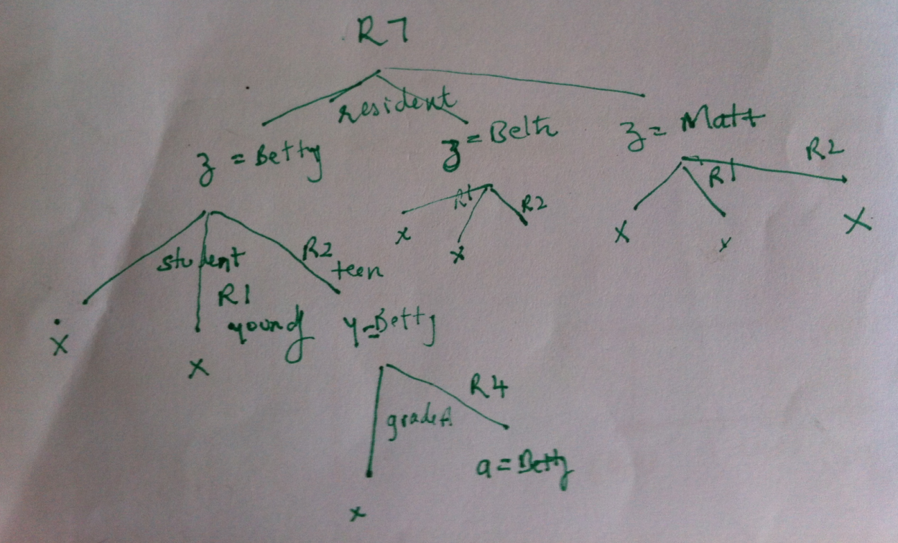

The order of rule firing is R2, R4, R7

**QUESTION 5 (Marks: 10)**

Consider the following fuzzy sets for input variables: humidity, temperature, area and for the output variable speed of exhaust fan. (the maximum height of all these fuzzy sets is one)







You are given the following rule base:

1. If humidity = less and temperature = cold and area = small then exhaust fan speed = very low
2. If humidity = average and temperature = cold and area = small then exhaust fan speed = low
3. If humidity = less and temperature = warm and area = small then exhaust fan speed = very low
4. If humidity = average and temperature = warm and area = small then exhaust fan speed = low
5. If humidity = less and temperature = hot and area = small then exhaust fan speed = medium
6. If humidity = average and temperature = hot and area = small then exhaust fan speed = medium
7. If humidity = less and temperature = cold and area = big then exhaust fan speed = medium
8. If humidity = average and temperature = cold and area = big then exhaust fan speed = high
9. If humidity = less and temperature = warm and area = big then exhaust fan speed = high
10. If humidity = average and temperature = warm and area = big then exhaust fan speed = very high
11. If humidity = less and temperature = hot and area = big then exhaust fan speed = high
12. If humidity = average and temperature = hot and area = big then exhaust fan speed = very high

You have to find a crisp value of exhaust fan speed when given the following inputs:

humidity = 8, temperature = 22, area = 450

Use root sum squares for inference and centroid method for defuzzification. Show all your steps. (use back side of this page for working)

**SOLUTION (NOTE: All working is not shown, only the answers are given)**

For humidity: µless = .4, µaverage = 0.6

For termperature: µcold = 0, µwarm = .8, µhot = 0.2

For area: µbig = .25, µsmall = 0.75

Rules 3,4,5,6,9,10,11,12 fire. As all the antecedents are connected via the ‘and’ operator, we construct the fuzzy value for the consequent using the min rule. So now using root sum square method:

µvery low = .4 µlow = .6 µmedium = sqrt(.2*.2+.2*.2) = .28 µhigh = sqrt(.25*.25+.2*.2) = .32

µvery high = sqrt(.25*.25+.2*.2) = .32

Using centroid method for defuzzification:

((.4*1.5)+.6*2+.28*3+.32*44+.32*4.5)/(.4+.6+.28+.32+.32) = 2.79